FlameIQ
Market Analysis
Executive Product Strategy Document
Prepared for Product Requirements Document (PRD)
Survey base: 113 responses · Nigeria · August 2026

1. Executive Summary

Overview
FlameIQ is an AI-powered LPG marketplace designed to predict when a user’s cooking gas will run out (from refill history, without hardware), connect them to verified vendors, and support ordering and delivery. This analysis combines primary survey evidence (113 responses) with publicly available industry context on Nigeria’s LPG market.

Key Findings (Survey-Backed)
- 91% of buyers experience unexpected gas shortages at least sometimes (43% often/very often).
- 97% rate AI prediction without hardware as useful or very useful (77% very useful).
- Top purchase criteria: clear price, fast delivery, verified/safe suppliers.
- 69% need emergency delivery within 1–2 hours when gas is already empty.
- Main barriers: hidden charges, unreliable delivery, AI distrust, privacy, complexity.
- Sellers (n=10) are mostly interested if commission is fair; preferred band 1–3%.

Major Opportunities
- Strong problem–solution fit on prediction + convenience for households.
- Fragmented, relationship-based supply side open to demand aggregation.
- Structural growth in Nigerian LPG adoption (government clean-cooking push).

Critical Risks
- Disintermediation: sellers can collect numbers and bypass the app.
- Trust and delivery reliability will determine retention more than feature novelty.
- Business (restaurant) demand is unvalidated in this survey.
- Commission sensitivity on the supply side.

Strategic Implications
Proceed with a household-first MVP centred on explainable AI prediction, transparent pricing, verified vendors, and fast fulfilment. Treat B2B features as phase-two pending dedicated research. Design the platform economics and retention loops explicitly against disintermediation.
PM Observation: The survey validates demand for the idea. It does not yet validate that users will reorder through the platform instead of calling the last vendor. That is the central product risk.

2. Industry Overview
Nigeria’s domestic LPG (cooking gas) market has expanded from a low base over the last decade. Public sources indicate consumption rose from roughly 130,000 MT in 2011 toward about 1 million MT by 2020–2021, with industry associations targeting multi-million-tonne annual demand later in the decade. Growth has been supported by policy emphasis on clean cooking, urbanisation, and increased supply from domestic and import sources.
Despite growth, distribution remains highly fragmented. Many households still rely on neighbourhood filling stations, informal retailers, phone/WhatsApp orders, and walk-ins. Digital ordering apps exist but have not fully displaced relationship-based buying. Price volatility has been material; national averages for a 12.5 kg refill have moved in a wide band (illustratively mid-to-high tens of thousands of naira in 2025 data from NBS-linked reporting), which heightens consumer sensitivity to transparent pricing.
Government targets have included substantial increases in household LPG adoption over multi-year horizons. Actual achievement depends on affordability, last-mile distribution, cylinder availability, and safety perception.
PM Observation: Industry growth creates a larger addressable base, but fragmentation and trust issues create the opening for a coordinated marketplace. FlameIQ’s bet is that prediction + verification can organise demand better than pure logistics apps.

3. Market Size Analysis
Precise, audited TAM/SAM/SOM figures specific to digital LPG ordering in Nigeria are not established in the survey and should not be invented. The following is a structured framing only.

TAM (Total Addressable Market)
All LPG consumed by Nigerian households and food-service businesses for cooking. Public estimates place national LPG demand on a multi-hundred-thousand to low-million MT trajectory with long-term growth targets stated by industry bodies. Monetisable value includes gas margin, delivery fees, and platform take rates — not only wholesale MT volume.

SAM (Serviceable Available Market)
Urban and peri-urban users (starting with Lagos and similar dense cities) who already buy LPG in cylinders, own smartphones, and are reachable by app-based ordering. This excludes rural biomass-dominant segments in the near term.

SOM (Serviceable Obtainable Market)
Initial 12–24 month capture within selected Lagos corridors where vendor density and 1–2 hour delivery are operationally realistic. SOM should be set from pilot conversion rates, not top-down percentages.

Assumptions & Required Research
- Average refill value and frequency by cylinder size need pilot measurement.
- Platform take rate (commission) must stay near seller tolerance (survey: mostly 1–3%).
- Additional research required: city-level LPG household penetration, restaurant cylinder volumes, and willingness-to-pay under real checkout conditions.
PM Observation: Do not use inflated top-down market sizes in the PRD or pitch without primary validation. Bottom-up unit economics from a Lagos pilot will be more credible.

4. Industry Trends
- Digital transformation: More utilities and essential goods moving to app-based ordering; gas remains relatively under-digitised versus food delivery.
- Mobile adoption: High smartphone penetration in urban Nigeria supports app distribution.
- AI adoption: Consumer openness to AI assistance is rising; survey shows strong stated interest in prediction, with residual accuracy scepticism.
- E-commerce behaviour: Users already comfortable with tracking and cashless payments in other categories; gas still skewed to cash/WhatsApp.
- Digital payments: Transfer, card, and mobile money are relevant; COD remains important per local practice.
- Logistics evolution: On-demand delivery networks exist; specialised LPG handling and safety constraints remain.
- Consumer expectations: Speed (1–2 hours in emergency), price clarity, and safety verification.
- Sustainability: Policy push toward cleaner cooking fuels supports LPG category growth, not specifically any one app.
PM Observation: Trend tailwinds exist, but category-specific trust and safety requirements are higher than for food or parcels. Copying a generic delivery playbook will underperform.

5. Customer Segmentation
Segment | Role | Priority | Evidence strength
Household cooks | Primary demand | High | Strong (101 of 103 buyers)
Food businesses | Secondary demand | Medium (later) | Weak (1 clear business respondent)
Gas plants / stations | Supply | High | Directional (n=10 sellers)
Delivery agents | Fulfilment | High | Directional
Platform admin | Operations | High | Internal

Household users
- Needs: Avoid surprise empty cylinders; fast refill; fair price; safe vendor.
- Pain: Unexpected shortage, stress, meal disruption, unclear pricing.
- Digital behaviour: Comfortable with WhatsApp/phone; open to apps if simple.
- Priority score: 9/10 for MVP.

Food businesses
- Needs: Multi-cylinder continuity, planned refills, bulk reliability.
- Pain: Operational stoppage (under-measured here).
- Priority score: 5/10 until researched.

Vendors / plants
- Needs: New customers, less chasing, clear orders, payment certainty.
- Pain: Insufficient demand, traffic, price competition.
- Priority score: 8/10 for launch readiness.

Delivery agents
- Needs: Clear jobs, fair pay, efficient routing, proof of delivery.
- Priority score: 8/10 operationally.

6. Customer Personas

Persona A — Urban Household Cook (Primary)
- Goals: Keep cooking uninterrupted; avoid last-minute panic.
- Motivations: Reliability, fair price, safety.
- Frustrations: Gas finishing mid-meal; calling multiple sellers; opaque prices.
- Buying behaviour: Monthly or bi-weekly refills; 3–12.5 kg cylinders; often via known seller or WhatsApp.
- Tech: Smartphone, OTP-comfortable, low patience for complex apps.
- Decision drivers: Price clarity, speed, verification.

Persona B — Food Business Operator (Secondary, under-validated)
- Goals: Zero downtime across multiple cylinders.
- Frustrations: Unexpected empty cylinder during service; coordinating suppliers.
- Decision drivers: Reliability, scheduling, volume pricing.
- Note: Persona is logical but not evidenced by this survey; interview before building deep multi-cylinder tooling.

Persona C — Gas Plant / Retailer
- Goals: Higher utilisation of stock and riders; predictable orders.
- Frustrations: Not enough new customers; price wars; traffic.
- Decision drivers: Commission rate, quality of leads, ease of use.

7. Survey Analysis — High-Impact Insights
Sample: 113 responses (103 buyers, 10 sellers). Buyer base is almost entirely household.
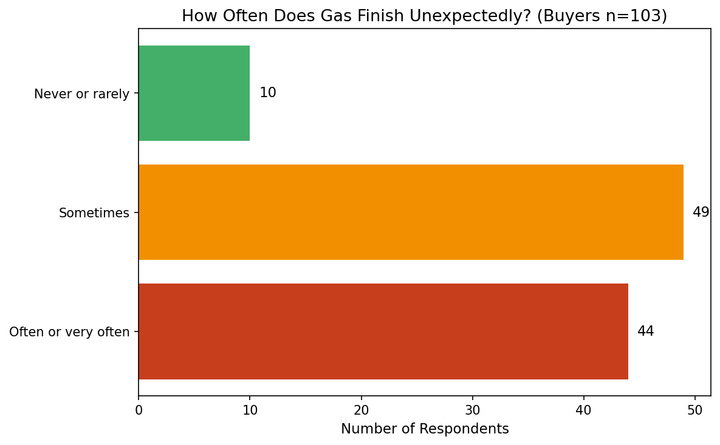
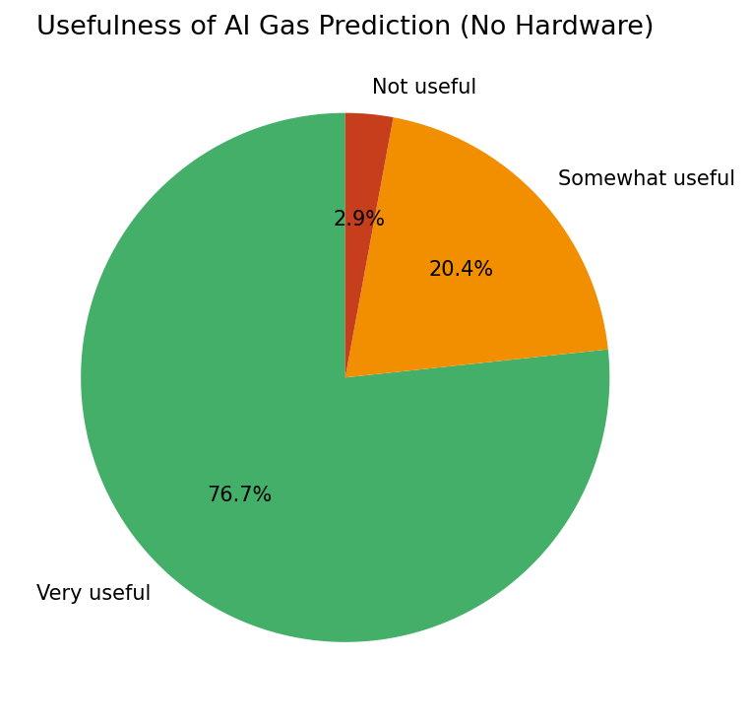
Hidden patterns and non-obvious findings:
- Prediction interest is high, but “don’t trust the AI” still ranks among top barriers. Stated usefulness ≠ trusted usage. The product must earn trust through transparent methodology and visible improvement after each fill log.
- Price anxiety outranks feature novelty. Hidden charges were the single most cited barrier (56 mentions). Any unclear fee will suppress conversion more than missing secondary features.
- Emergency speed requirement is extreme (69% within 1–2 hours). This is an operations constraint, not a UI preference. Launch geography must be chosen where this SLA is achievable.
- Trust in unknown riders is conditional (only ~30% full yes). Verification and tracking are conversion infrastructure.
- Business pain is almost invisible in the data because businesses barely responded. Do not extrapolate restaurant urgency from household answers.
- Seller motivation is demand, not digitisation for its own sake. “Not enough new customers” was the top seller challenge.
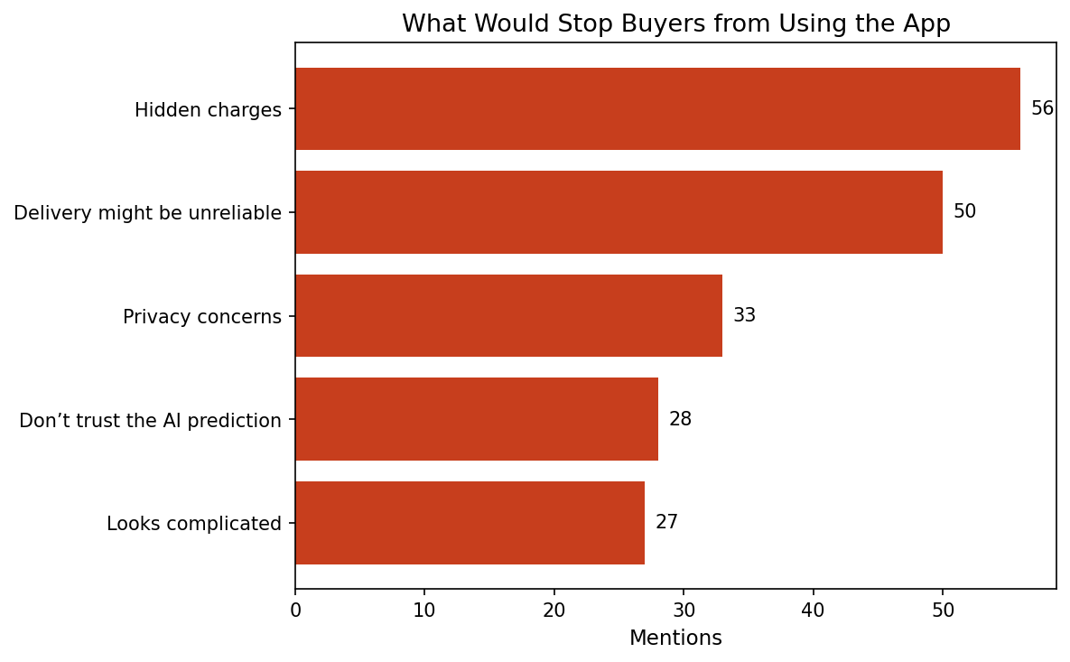
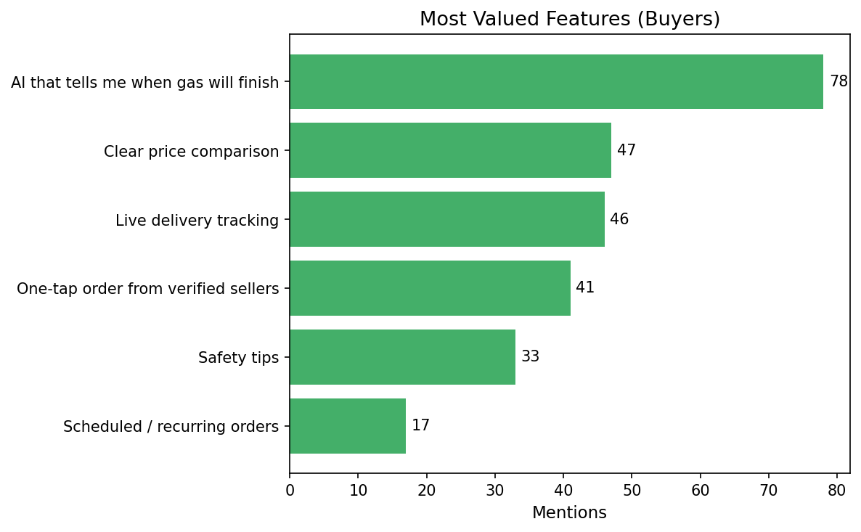
PM Observation: The survey says “build prediction.” The same survey says “users will leave if delivery fails or prices look dishonest.” Sequence the roadmap accordingly.

8. Customer Behaviour Analysis
- Purchase frequency: Majority refill once a month or less; a sizable minority every two weeks.
- Cylinder mix: 6 kg and 12.5 kg lead; 3 kg meaningful; large commercial sizes rare among surveyed buyers.
- Ordering channels today (sellers): WhatsApp/phone and walk-ins dominate.
- Decision process: Price and speed first; verification third; ratings matter but less than fundamentals.
- Payment: Survey did not yield a clean single payment-method distribution; COD and transfers remain culturally important — confirm in pilot.
- Loyalty / switching: Relationship-based loyalty to known sellers is the default. Platform must beat the convenience of “call my gas man.”
- Emergency behaviour: High urgency when empty; prediction is valuable precisely because it reduces emergency frequency.
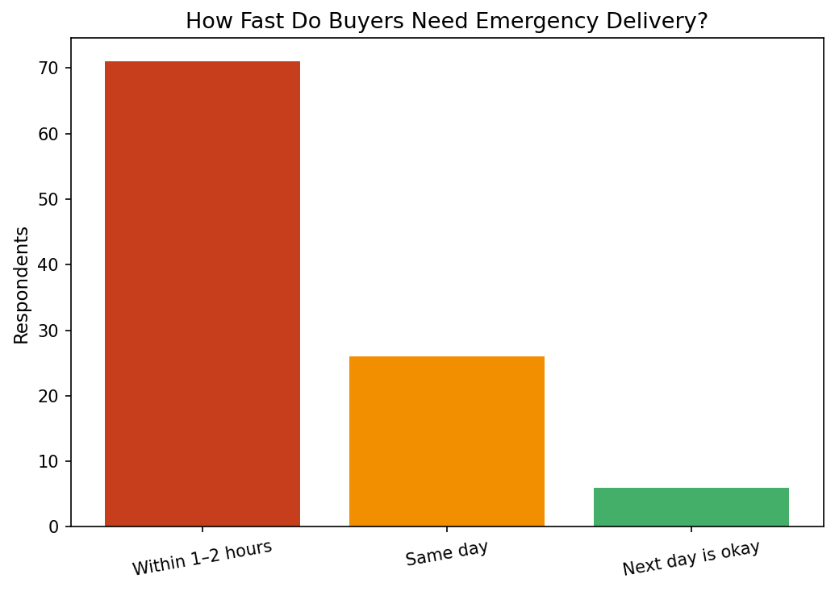
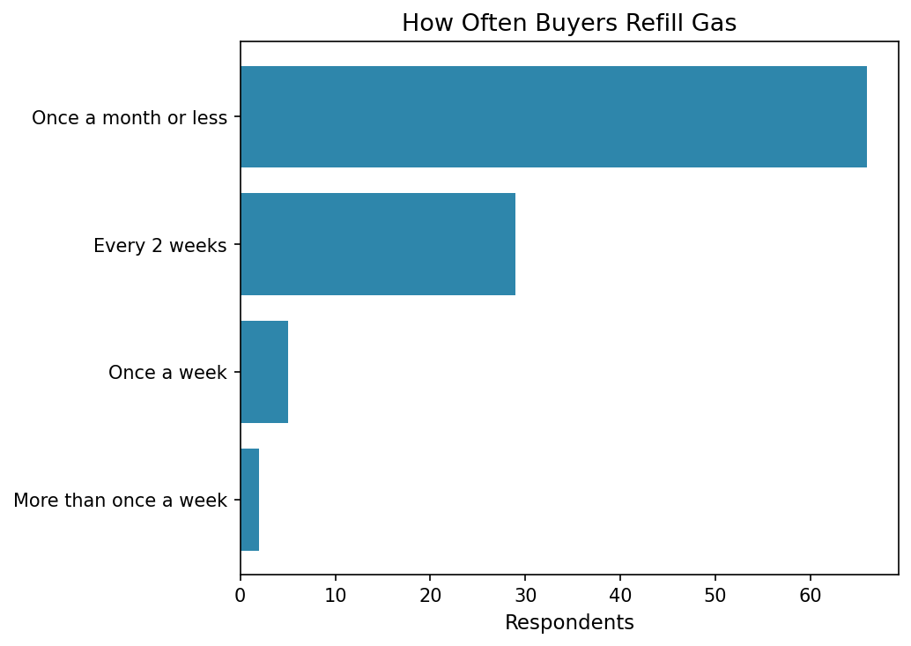

9. Problem Validation
Problem | Frequency signal | Severity signal | Business impact | Rank
Unexpected empty cylinder | 91% sometimes+ | Meal delay 73; stress 56 | High for retention | 1
Unclear / unfair pricing | Top criterion + top barrier | High trust damage | High for conversion | 2
Slow / unreliable delivery | 69% want ≤2 hrs; top barrier | High | High for repeat use | 3
Finding trusted vendor | Verified/safe = 42 mentions | Medium-High | Medium-High | 4
Manual estimation of remaining gas | Implied by prediction demand | Medium | Core wedge | 5

Root causes: Fragmented retail; weak digital inventory/visibility; relationship-based markets without shared reputation systems; no lightweight consumption feedback loop for consumers.

10. Market Gap Analysis
- Existing solutions often solve ordering OR delivery, rarely trustworthy prediction without hardware.
- Traditional sellers solve familiarity but not transparency, alternatives, or proactive reminders.
- Generic logistics apps lack LPG-specific trust, safety, and cylinder workflows.
- Hardware IoT monitors exist in some markets but add cost and friction — FlameIQ deliberately avoids this.
- Unmet need: “Tell me before I run out, show me a fair price, and get a verified person to me quickly.”
- Inefficiency: Sellers struggle for new demand while buyers struggle for reliable supply — classic matching problem.

11. Competitive Landscape
Named digital players in or adjacent to Nigerian LPG delivery include apps and services such as NaijaGasOnline, Smart Energies, Jumandi Gas, and similar local operators, alongside ubiquitous WhatsApp/phone ordering and walk-in stations. Feature depth varies and changes quickly; the table below is a positioning frame, not a live feature audit.
Player type | Prediction | Verified vendors | Price clarity | Tracking | Primary weakness vs FlameIQ
Neighbourhood seller / WhatsApp | No | Personal trust only | Often opaque | No | No proactive prediction; limited choice
Local gas delivery apps | Rare / none | Varies | Varies | Often yes | Weak or no AI prediction wedge
General on-demand logistics | No | Not gas-specialised | Varies | Yes | Not built for LPG safety/trust
Hardware smart monitors | Yes (sensor) | N/A | N/A | N/A | Hardware cost & adoption friction
FlameIQ (intended) | Yes (no hardware) | Yes | Yes | Yes | Must prove accuracy + ops

Direct competitors: Digital LPG ordering/delivery services in Nigeria.
Indirect competitors: Known local sellers, general delivery platforms, offline stations.
Substitutes: Keeping spare cylinders; over-buying; switching fuel where possible.
PM Observation: Competition is less about who has an app and more about who earns habitual reordering. Prediction is the wedge; operations are the moat.

12. SWOT Analysis
 | Helpful | Harmful
Internal | Strengths: Clear problem fit; strong stated demand for AI prediction; no hardware barrier; dual-sided value story | Weaknesses: Unproven prediction accuracy in production; thin business-user evidence; delivery SLA hard to hit; brand trust from zero
External | Opportunities: LPG adoption growth; fragmented supply; under-digitised category; clean-cooking policy tailwinds | Threats: Disintermediation; price wars; better-funded logistics entrants; regulatory/safety incidents; AI scepticism

13. PESTLE Analysis
- Political: Clean cooking and domestic gas utilisation policies support category growth; policy execution risk remains.
- Economic: Inflation and LPG price volatility increase price sensitivity; disposable income pressure may delay premium features.
- Social: Urban household reliance on LPG; safety concerns around cylinders and unknown riders.
- Technological: Smartphone ubiquity; AI acceptance rising but accuracy must be demonstrated; payments infrastructure improving.
- Legal: Consumer protection, data privacy, and LPG handling/safety regulations require careful compliance design.
- Environmental: Shift from biomass to LPG aligns with sustainability narratives; platform can emphasise safer, cleaner cooking indirectly.

14. Porter’s Five Forces (Qualitative)
- Rivalry: Moderate and rising among local delivery apps; still low sophistication on prediction.
- New entrants: Relatively easy to launch an ordering app; hard to sustain ops + trust + density.
- Supplier power (vendors/agents): Moderate–high locally; platform must offer clear demand value.
- Buyer power: High — switching to phone the last vendor is easy.
- Substitutes: Spare cylinders, known sellers, non-LPG fuels in some segments.
Overall: Attractive if density and trust are achieved; structurally challenged if the app becomes a thin dispatch layer.

15. Product–Market Fit Analysis
Evidence supporting fit:
- High frequency of the core problem (unexpected shortage).
- Very high stated usefulness of the proposed solution (AI prediction without hardware).
- Feature preference ranking aligns with the planned MVP.
Adoption barriers:
- Trust in AI accuracy.
- Trust in unknown delivery personnel.
- Fear of hidden charges.
- Habit of calling a known seller.
Key success factors:
- Prediction that feels right after 2–3 fills.
- Zero-surprise pricing.
- Delivery performance matching emergency expectations in launch zones.
- Seller economics that keep quality partners on the platform.

16. Go-to-Market Recommendations
- Initial launch city: Lagos — density, smartphone usage, and LPG prevalence make SLA more achievable than national rollout.
- Customer acquisition: Target household corridors with referral incentives; content around “never get stranded mid-cooking”; partnerships with estates/compounds.
- Vendor acquisition: Lead with “new customers, clear orders, low commission (1–3% target band)”; prioritise plants/stations already doing delivery.
- Marketing channels: WhatsApp, local community groups, targeted social, outdoor in launch LGAs; avoid broad national spend early.
- Pricing strategy: Transparent gas + delivery fee; optional premium later; avoid mandatory subscription at launch.
- Retention: Prediction alerts as the habit loop; post-delivery ratings; reorder shortcuts; reliability SLAs.

17. Risks and Assumptions
Type | Risk | Mitigation direction
Product | AI prediction feels inaccurate | Conservative estimates; show confidence; learn from fills
Operational | Cannot hit 1–2 hour emergency delivery | Constrain launch geography; partner density first
Market | Users bypass app after first order | Prediction + multi-vendor options + reliability rewards
Supply | Sellers reject commission | Stay in 1–3% band; prove incremental demand
Regulatory/Safety | Incident involving delivered LPG | Vetting, training standards, insurance posture
Financial | Unit economics negative at low density | Corridor-based launch; watch contribution margin per order
Research | B2B demand overestimated | Do not build multi-cylinder deep features until interviewed

Critical assumptions to test in pilot: prediction error rate; reorder rate through app vs churn to direct calls; seller retention at stated commission; actual emergency delivery times.

18. Strategic Recommendations

Immediate (0–3 months)
- Lock MVP scope: prediction + transparent order + verified vendors + tracking + COD/transfer.
- Run Lagos corridor selection based on vendor density.
- Instrument prediction accuracy metrics from day one.
- Conduct 10–15 restaurant/canteen interviews to validate or defer B2B.
- Finalise seller commission policy in the 1–3% range.

Short-term (3–12 months)
- Launch soft pilot; measure reorder rate and disintermediation.
- Tighten delivery SLAs only where density supports them.
- Build rating/verification credibility loops.
- Iterate prediction model with real fill data.

Long-term (1–3 years)
- Expand corridors, then cities, only after unit economics work.
- Selectively add business tooling if interviews and pilot demand support it.
- Explore premium tiers only after core habit is proven.

19. Conclusion
Nigeria’s LPG market is growing and structurally fragmented. Consumers clearly recognise the pain of unexpected empty cylinders and respond positively to AI prediction without hardware. The commercial opportunity is real but execution-heavy: trust, price honesty, and delivery reliability will decide outcomes more than feature breadth.
FlameIQ’s path is viable if the team treats prediction as the acquisition wedge and operational excellence as the retention system.

Executive Decision
Decision: Proceed with MVP development.
Confidence level: Medium-High on problem/solution relevance; Medium on ability to retain users against disintermediation without strong ops.
Reasons to proceed:
- Problem frequency validated (91%).
- Solution concept strongly endorsed (97% useful).
- Feature priorities align with a focused MVP.
- Sellers show conditional willingness to join.
Reasons for caution:
- Business segment unvalidated.
- Delivery SLA is demanding.
- Trust and hidden-charge sensitivity are high.
- Seller sample is small.
Condition: MVP success criteria must include prediction usefulness ratings, app reorder rate (not just first orders), delivery time distribution, and seller retention — not downloads alone.

Document owner: Product · Audience: PRD, leadership, investors, engineering, analytics · Evidence base: FlameIQ survey (n=113) + public industry sources · Statistics not present in survey or cited public sources were not invented.

